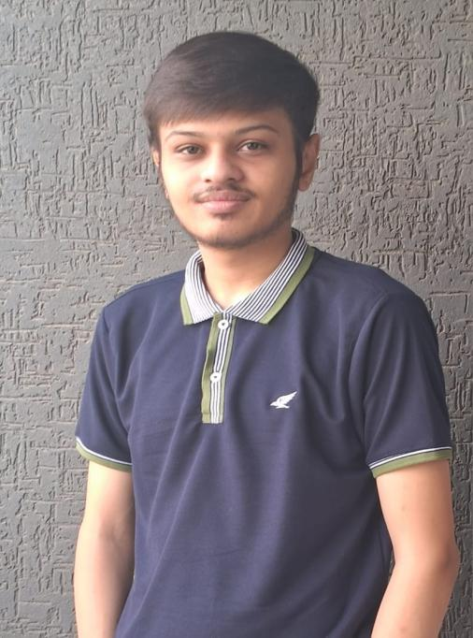٠٠٠٠٠

**Hobbies**

• **Travel**

**• Piano**

**• Drum**

**• Music**

**• Rain Camping**

**Languages**

★ **Gujarati**

**Basic Information**

Birthday: 2005.10.5

Live now:Ahmedabad

Years old : 19

**[LinkedIn](https://www.linkedin.com/in/raj-patel04s/)**

**[Github](https://github.com/RajPatel7115)**

★ **English**

★ **Hindi**

• Communication

• Teamwork

• Time Management

• Positive Attitude

• Attention To Details

**Soft Skill**

• One of my disadvantage is i hesitate to speak up or ask question in class or group settings but i am pushing my self to be more confident because in the future i want become skilled developer and want to take small responsibility like lead a team or project, to do that i need to improve myself and I can do it.

**Self-evaluation**

• Currently learning java backend devlopement and fimilar with html, css scripts and want to learn as much as possible in c, c++ and java or python. One of my skill or advantage is i learn things very quickly and understand it first how things work step by step and in the future want to work in strong environment

**skill**



**Dangee Dums ( 2024 - Present )**

• Currently working as billing data manage team in dangee dums company

• Our team manage data of created bills from 47 outlets all over the gujarat

• Sometimes we manage CRM orders and server of billing software and transfer wrong punch of bills to deduction of outlet or team.

**Work experience**

**Sigma Institute of Engineering ( 2021 - 2024 )**

Software engineering in diploma. At baroda, near ajva nimeta road.

**Diwan Ballubhai Madhyamik School ( 2019 - 2021 )**

Gujarati medium school secondary, near kankariya ahmedabad.

From standard nine to ten.

**Diwan Ballubhai Prathmik School ( 2011 - 2019 )**

Gujarati medium school, near kankariya ahmedabad.

From standard one to eight.

rajpateliil1234@gmail.com

**Contact information**

**Raj Patel**

★ **Java Backend Devlope**r ★

**Education background**